Read the title and make a prediction.
Underline key words in the questions.
(This means they have to read the questions BEFORE reading the selected text!)
Notice the numbered paragraphs.
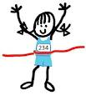
Now read the text.
Eliminate wrong answers.
Re-read and prove your answers!
(Student must find their answer in the text and prove it by underlining it.)
Select the best answer.
This may seem like a lot, but having a quick and organized approach to reading multiple passages and answering questions about each passage, WILL help your students to do their best!

